**SINGARENI COLLIERIES WOMEN’S DEGREE COLLEGE**

**DEPARTMENT OF PHYSICS**

**DEPARTMENTAL ACTIVITIES-2021-2022**

|  |  |  |  |  |  |
| --- | --- | --- | --- | --- | --- |
| **S.NO** | **DATE** | **ACTIVITY** | **RESOURCE PERSONS/ ORGANIZATION** | **FACULTY INVOLVED** | **PHOTO** |
| 1 | 29th Sep, 2021 | National Webinar | Department of Physics, SCWDC, Kothagudem, Telangana | Dr P. Suneeta  In charge of the Physics Dept. |  |

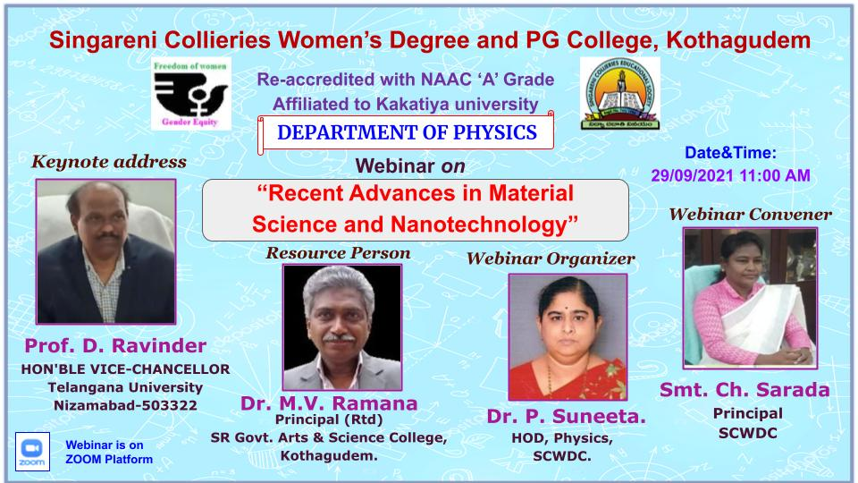

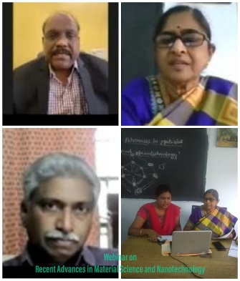

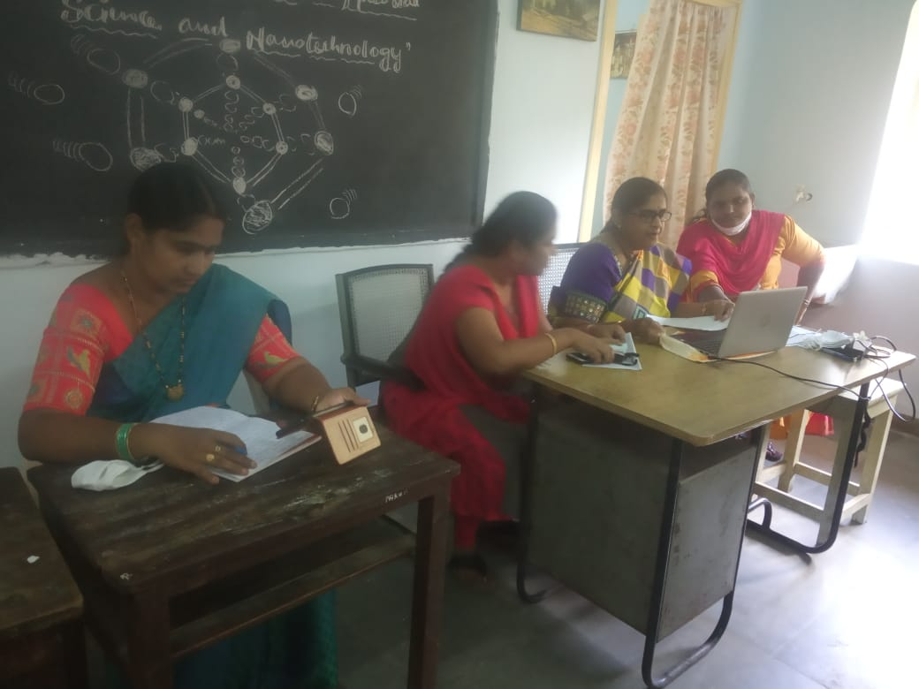 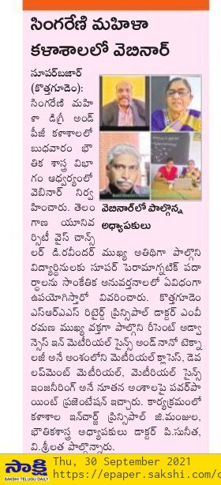

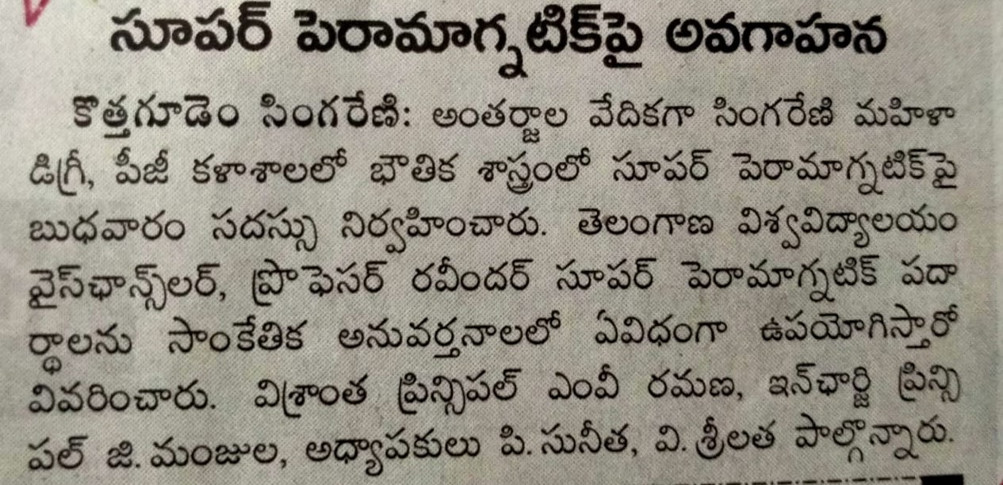

|  |  |  |  |  |  |
| --- | --- | --- | --- | --- | --- |
| **S.NO** | **DATE** | **ACTIVITY** | **RESOURCE PERSONS/ ORGANIZATION** | **FACULTY INVOLVED** | **PHOTO** |
| 2 | 5th Oct, 2021 | Swachataki  Sevba | SCWDC, Kothagudem, Telangana | Dr P. Suneeta  In charge of the Physics Dept.  V. Srilatha |  |

